IP Geolocation API

🌐 What Is an IP Geolocation API?
# Source: Chatgpt (GPT-5-Mini) at [1/19/2026]
An IP Geolocation API is a web service that lets you determine the physical location of a device or user based on their IP address.
It returns data like:
- 📍 Country, city, region
- 🕒 Timezone
- 🌐 ISP and network info
- 📡 Latitude & longitude
- 💻 Device or connection type (optional)

✅ What IP Geolocation APIs Can Do
# Source: Chatgpt (GPT-5-Mini) at [1/19/2026]
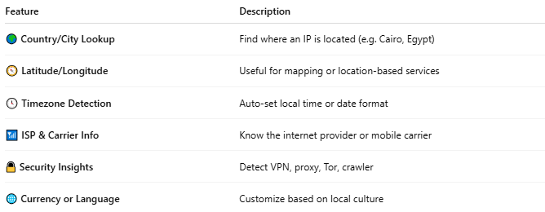

Feature | Description
🌍 Country/City Lookup | Find where an IP is located (e.g. Cairo, Egypt)
🧭 Latitude/Longitude | Useful for mapping or location-based services
🕓 Timezone Detection | Auto-set local time or date format
📶 ISP & Carrier Info | Know the internet provider or mobile carrier
🔒 Security Insights | Detect VPN, proxy, Tor, crawler
🌐 Currency or Language | Customize based on local culture

🧩 Popular IP Geolocation APIs
# Source: Chatgpt (GPT-5-Mini) at [1/19/2026]
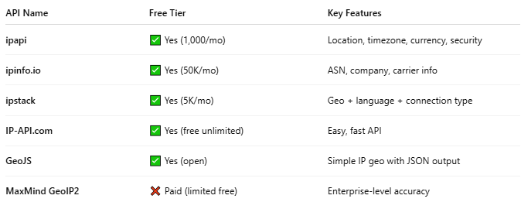

API Name | Free Tier | Key Features
ipapi | ✅ Yes (1,000/mo) | Location, timezone, currency, security
ipinfo.io | ✅ Yes (50K/mo) | ASN, company, carrier info
ipstack | ✅ Yes (5K/mo) | Geo + language + connection type
IP-API.com | ✅ Yes (free unlimited) | Easy, fast API
GeoJS | ✅ Yes (open) | Simple IP geo with JSON output
MaxMind GeoIP2 | ❌ Paid (limited free) | Enterprise-level accuracy

📤 Example: IP Geolocation via ip-api.com
# Source: Chatgpt (GPT-5-Mini) at [1/19/2026]
Request:
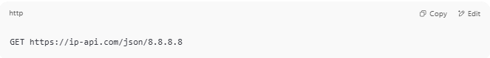
GET https://ip-api.com/json/8.8.8.8

Response:
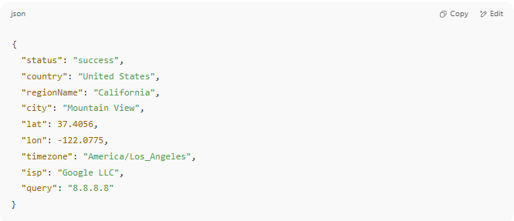
{
"status": "success",
"country": "United States",
"regionName": "California",
"city": "Mountain View",
"lat": 37.4056,
"lon": -122.0775,
"timezone": "America/Los_Angeles",
"isp": "Google LLC",
"query": "8.8.8.8"
}

🔄 Replace 8.8.8.8 with any valid IP or use:
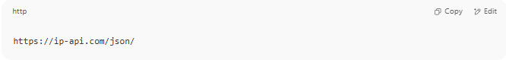
https://ip-api.com/json/

(to detect the current user's IP automatically)

🧪 Use Cases
# Source: Chatgpt (GPT-5-Mini) at [1/19/2026]
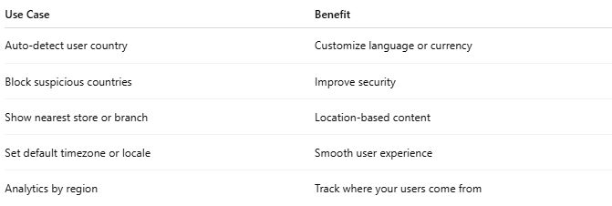

Use Case | Benefit
Auto-detect user country | Customize language or currency
Block suspicious countries | Improve security
Show nearest store or branch | Location-based content
Set default timezone or locale | Smooth user experience
Analytics by region | Track where your users come from

🛠️ Testing in Postman
# Source: Chatgpt (GPT-5-Mini) at [1/19/2026]
- Method: GET
- URL:
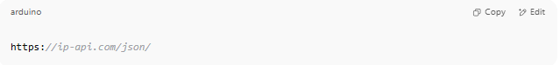
https://ip-api.com/json/

- Click "Send"
✅ You’ll see JSON with your IP info.

Example
# Source: Windows ScreenShots at [1/19/2026]
http://ip-api.com/json/8.8.8.8
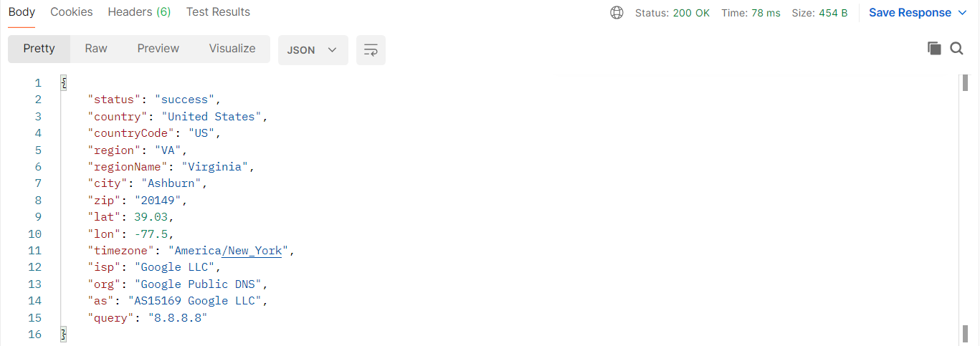

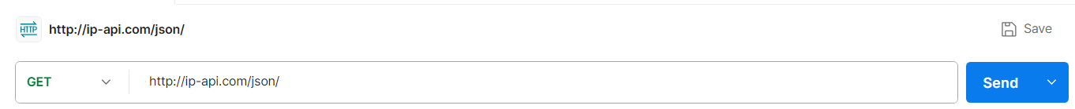
http://ip-api.com/json/
